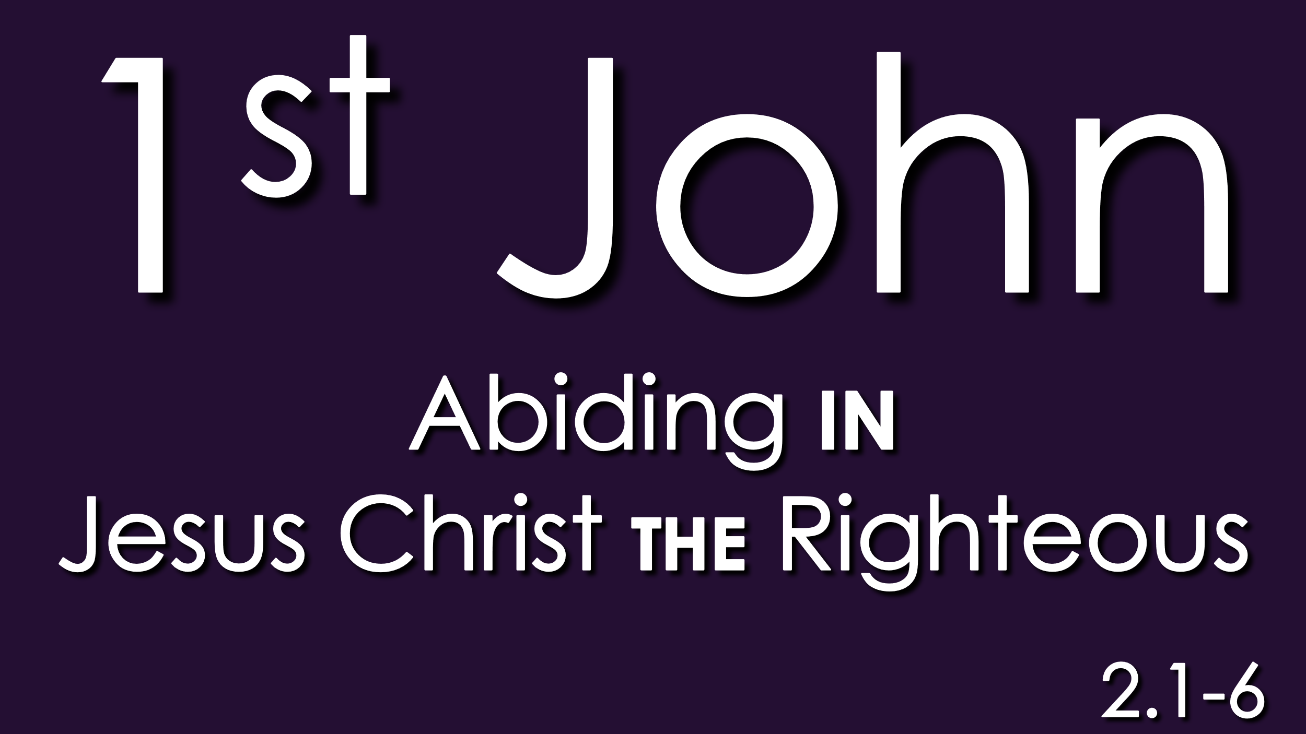

Would you please stand for the reading of God’s Word?

2 My little children, I am writing these things to you so that you may not sin. But if anyone does sin, we have an advocate with the Father, Jesus Christ the righteous. ² He is the propitiation for our sins, and not for ours only but also for the sins of the whole world. ³ And by this we know that we have come to know him, if we keep his commandments. ⁴ Whoever says “I know him” but does not keep his commandments is a liar, and the truth is not in him, ⁵ but whoever keeps his word, in him truly the love of God is perfected. By this we may know that we are in him: ⁶ whoever says he abides in him ought to walk in the same way in which he walked.

Please be seated. May God always bless the reading of His Word among His people.

What is most important is most often more caught than taught. Caught through observation and imitation, rather than taught by words and formulas.

Life’s most important virtues, like self-discipline, or resilience … or kindness, or forgiveness … are caught through observing those virtues in another person and then imitating that person in the application of those virtues.

Discipleship of the Lord Jesus is more caught than taught. That’s where we are in these verses, particularly verses 3 through 6. We’ll spend all of our time this morning in verses 3 through 6. That’s the life of discipleship to the Lord Jesus being given to us, particularly in verses 3 to 6.

First we need to answer some questions from these three verses.

First question: What does “knowing” mean in these three verses?

Some form of the word “know” is used 42 times in this short little letter of 1st John. That’s a lot for five relatively short chapters: 42 times.

You can know something in terms of “data”: raw factual knowledge. Like Matt Amodio and his 38-game win streak on Jeopardy. You can know something to be true rather than false. Like the young jewelry apprentice learns to spot a fake at a glance. You can know a person. Like I know Greg Peck or I know James Bulmahn … I could pick them out in a police line-up any time!

But what “know” means in these three verses is more than knowing raw data; is more than knowing truth from falsehood; is more than knowing an individual apart from a group.

In these three verses, when John writes about knowing, John is … coming at knowing … through what God said by the prophet Jeremiah:
“I will put my law within them, and I will write it on their hearts. And I will be their God, and they shall be my people. And no longer shall each one teach his neighbor and each his brother, saying, ‘Know the Lord,’ for they shall all know me, from the least of them to the greatest,’ declares the Lord. For I will forgive their iniquity, and I will remember their sin no more.”
Jeremiah 31.33-34

When John writes about knowing John is … coming at knowing … through what God said by the prophet Ezekiel:
“And I will give you a new heart, and a new spirit I will put within you. And I will remove the heart of stone from your flesh and give you a heart of flesh. And I will put my Spirit within you, and cause you to walk in my statutes and be careful to obey my rules.
Ezekiel 36.26,27

This ‘knowing’ is an internal, experiential knowledge of God. This ’knowing’ is a dynamic spiritual relationship with God.

But again, that begs the question: “How?” How does this experiential knowledge of God happen? How do we truly come to know God?

By being like Jesus.
By imitating Jesus.
By devoting ourselves to Jesus.

Let me give you a simple illustration. What would happen to my cell phone if I plugged it in … directly plugged it in …to the main line of a nuclear reactor? Blow it up, right? My little Samsung phone is not made to handle that kind of current. (Neither is an I-Phone, by the way!)

Jesus came to reveal God to us. Jesus came to, as John says in his gospel, to make God known to us; to explain God to us.

You see, loved ones, on this side of the vale, we simply cannot know God directly. On this side of eternity our little selves cannot handle … the God current. We are not wired for it … yet. No man can seen God and live.

But God the Son … the Word made flesh … Jesus … shows us … God. Jesus translates to us … God.

In these 3 verses, “knowing” means a dynamic, internal, experiential knowledge of God IN JESUS.
No one who denies the Son has the Father. Whoever confesses the Son has the Father also.
1 John 2.23

Jesus is the way, the truth and the life. The way to the Father. The truth of the Father. The life from the Father.

As Jesus prayed in John 17,
“And this is eternal life, that they know you the only true God, and Jesus Christ whom you have sent.”
John 17.3

Second question: What does “keep his commandments” mean here in these verses?

Well, right away, let’s just state the obvious. “Keep His commandments” DOES NOT mean … keep the Ten Commandments. This is a letter almost certainly written to Gentile Christians having little or any background with the 10 Commandments or with the rest of the Law of Moses. The “commandments” here DO NOT refer the Old Testament Law.

We need to go chapter 3. John tells us what “His commandments” are:
And this is his commandment, that we believe in the name of his Son Jesus Christ and love one another, just as he has commanded us. Whoever keeps his commandments abides in God, and God in him.
And by this we know that he abides in us, by the Spirit whom he has given us.
1John 3.23,24

What does “keep his commandments” mean? To believe in Jesus; to love on another. To believe in Jesus Christ and to love one another: these are the commandments of God.

And again, “belief” in Jesus, here, is not just mental assent. “Belief” in Jesus, here is not just:
- “My Mom or my Dad took me to church when I was little and I learned about Jesus and about the five loaves and the two fish and I learned that Jesus was really, really nice.”
‘Belief” in Jesus, here is not just:
- “Oh yes … I remember raising my hand when all the heads were bowed and all the eyes were shut and I prayed that sinner’s prayer and I’ve actually turned my cheek a few times over the years.”

I take us back to John chapter 6. Jesus said:
Do not work for the food that perishes, but for the food that endures to eternal life, which the Son of Man will give to you. For on him God the Father has set his seal.” Then they said to him, “What must we do, to be doing the works of God?” Jesus answered them, “This is the work of God, that you believe in him whom he has sent.”
John 6.27-29

And again, Jesus prayed to God in John 17.8, “they have believed that you sent me” and also
“I do not ask for these only, but also for those who will believe in me through their word, that they may all be one, just as you, Father, are in me, and I in you, that they also may be in us, so that the world may believe that you have sent me.
John 17.20,21

What does “keep his commandments” mean? To believe in Jesus. To love on another

This is having an oxygen tank under water belief. This is food to a starving stomach belief. This is sight to blind eyes belief. This is life-changing belief; life-sustaining belief.

I have found what I’m looking for in Jesus. I am satisfied in Jesus. I am content in Jesus. I can do all things through Jesus. My hope, my purpose, my identity, is in Jesus.

THIS is the “belief” in Jesus that keeps the commandments of God. Beyond death and dying belief in Jesus. Beyond the grave belief in Jesus.

And this is his commandment, that we believe in the name of his Son Jesus Christ, and that we love one another.

This was Jesus’ command after He had washed the disciples’ feet on the night He was betrayed.
A new commandment I give to you, that you love one another: just as I have loved you, you also are to love one another. By this all people will know that you are my disciples, if you have love for one another.”
John 13.34,35
What does “keep his commandments” mean? To believe in Jesus. To love on another.

Do you remember when Jesus was asked: “What is the greatest commandment?” What did Jesus say?
- You shall love the Lord your God, with all your heart and with all your soul, and with all your mind, and with all your strength. And the second is like unto it. You shall love your neighbor as yourself.
Love God. Love your neighbor.

For the follower of Jesus truly attempting to actually follow Jesus in community; in relationship. in fellowship; with other followers of Jesus.

What is the great commandment? Very similar to love God, love your neighbor. Believe in Jesus. (God-the-Son) Love one another.

Quit trying … then to suss out formulas for living the Christian life. Quit trying … then to parse, to define and to program your life with God.

And I know that flies in the face of quite of few of you and how you try to manage your Christian life.
    - “I know if I’m doing these things, then I’m okay. I’m doing what I should. I need bench-marks. I need to know that I’m getting it right; that I’m on the right path; that I’m doing the right thing. I need more definition. I need more precision.
      - This loosy-goosy … just go … love God and love people … kind of approach is too … indefinite for me

Just a few months ago, I preached, “God give us more boring Christians.” And I meant it. I am a big believer in developing a life of routine and good habits, and spiritual disciplines. Of living a quiet life where you’re content in Christ with your life.
I really believe that, even if the world call such a life a boring life.

But it is quite possible for you, or for me, to spend so much time and energy, organizing our Christian life, and charting and arranging our Christian life … that we actually forget … to live our Christian life beyond the safe and comfortable boundaries of our routines and our preparations.
Believe in Jesus.
Love one another.
Pro-actively, positively, grow in your life with Jesus and go in your love and service of your fellow-believers first and then of all people; all your neighbors; because everyone is your neighbor.

Third question, and then we glean applications from these verses.
What does, “the love of God is perfected” mean here?

Let the Bible interpret the Bible, and begin interpreting by looking at the closest places. “Perfected” here, means to bring to completion; to complete something.

Doesn’t mean the flawless diamond; 100% purity. It means the process has gone as far as it can possibly go. Doesn’t mean purity; it means completion.

There are three other places in 1st John where this word, “perfected” and the love of God, are laid side by side.
- 1st John 4.12: If we love one another God’s love is perfected in us.
- 1st John 4.17 God’s love is being perfected in us so that we have confidence for the day of judgement.
- 1 John 4.18: Perfect love casts out fear. Whoever fears has not been perfected in love.

So … what is meant by “God’s love is perfected in us”? Our love for God is being perfected as we live our lives in Jesus loving one another. Our love for God is being perfected as we grow in confidence that God truly loves us in Jesus.

God …perfecting His love in us is a life-long process. Remember: This is love: not that we have loved God but that God has loved us and sent His Son to be the propitiation for our sins.

This is love: He laid down His life for us and we lay down our lives for our brothers and sisters.

What are the applications from the text?

First: What keeping His commandments tells me.

Remember: keeping His commandments are: Believing in Jesus & loving one another.

Keeping His commandments tells me …My brethren are God’s gifts to me.

My brothers and sisters in the community of faith are the first place where God’s love to me in Jesus is made real; where God’s love to me in Jesus first comes to life.

Now … hear me out.

In the fall of the year I return to the Lord of Rings. Before Bilbo Baggins vanishes from his birthday celebration he makes a short speech and he says this about the people in his community:
I don't know half of you
half as well as I should like
and I like less than half of you
half as well as you deserve.

Bilbo’s a little drunk when he says this. But he’s saying what is a plain truth. And I believe it’s a plain truth that can be applied to church:

You can’t know everyone well. And some of the people that you do know well you don’t really like. I think that’s true about church. I do. We are up a creek, people, if we seriously expect that everyone here is going to be really, really, really close. Not gonn’a happen.

And I know what I’m saying flied in the face of … well … so much of what is promoted about “church” today.
“Come to our church
and we will connect with you;
and you will connect with us;
and we will find community
and we will all be …
just happy, loving people
right away.”

That’s a church marketing lie.

The New Testament truth about the church is actually much more :

Believe in Jesus and become a member of His body PEOPLE who are radically different from one another and have to learn to live with one another in spite of their differences.

And not only “peacefully co-exist” with ne another but who actually learn over time, through many trials and hardships, to bear with one another, and to support one another, and in the end to love one another

And not because there’s anything particularly sparkling about the other person but because you love them because CHRIST DIED FOR THEM.

THAT’S the New Testament truth about the church. (Read your Bibles.)

Isn’t is true that you can pick your friends but you can’t pick your family? Well, it is equally true (at least, this is the way it’s supposed to be in the New Testament): You can pick your friends but you can’t pick your brother in Jesus; you can’t pick your sister in Jesus. Those are the brethren God gives you in Jesus.

Now …bear with them; suffer with them; rejoice with them; hope for them; Begin to see in them the value, the treasure of what God sees in them.

Because, loved ones, while you are doing that for them, because of Christ Jesus; they are doing that for you. Also, because of Christ Jesus.

Sometimes, you’re not the easiest person to get along with. Did you know that? Well … it’s true. Or … on any given day it can be.

What keeping His commandments tells me is that I need you. I am incomplete as a follower of Jesus without you. Over the course of my life in Jesus YOU are the person God uses to complete God’s love in me.

That’s the first application. What keeping His commandments tells me is how critically important it is for me to live out my belief in Jesus by loving you in Jesus.

The second application is much shorter because it follows the first.

Second: What not keeping His commandments tells me (& others.)

Verses 4, and the first part of verse 5.

If I don’t keep His commandments by believing in Jesus and loving you, but I’m telling people; I’m telling myself: “Oh yes, I know God.” Then I’m a living a lie.

You see, loved ones, Biblically, there is no such thing as a follower of Jesus who intentionally chooses to live without the community of other followers of Jesus. Biblically, it doesn’t happen.

You show me someone claiming to be a Christian who intentionally chooses as a way of life to live apart from other Christians and I’ll show you someone who is at least a liar and who I doubt very much is a Christian at all and again at the least – deceiving him or herself

The third application comes from the last full sentence: second part of verse 5 and the rest of verse 6.

My assurance as a Christian is walking in the same way Jesus walked.
- BY THIS WE KNOW

(Preach a little)

