Would you please stand for the reading of God’s Word?

¹ That which was from the beginning, which we have heard, which we have seen with our eyes, which we looked upon and have touched with our hands, concerning the word of life— ² the life was made manifest, and we have seen it, and testify to it and proclaim to you the eternal life, which was with the Father and was made manifest to us— ³ that which we have seen and heard we proclaim also to you, so that you too may have fellowship with us; and indeed our fellowship is with the Father and with his Son Jesus Christ. ⁴ And we are writing these things so that our joy may be complete.

Please be seated. May God always bless the reading of His Word among His people.

John writes differently, doesn’t he?

This is a letter, but it sure doesn’t begin like most letters you and I know. Dear Mary. Dear Bob. Even: To whom it may concern. That’s how we begin our letters today. And this letter certainly doesn’t begin like that.

And this letter doesn’t even begin like a lot of the letters in the New Testament:

A letter to a church: Paul … to all those in Rome. Or a letter to a person: Paul … To Timothy.

Or different authors in the New Testament, with their letters. James begins his letter: James … To the twelve tribes of the dispersion. Peter begins his letters Peter … To those who are elect exiles of the Dispersion.
Even John’s other letters begin differently than this letter: 2nd John: The Elder to the elect lady and her children. 3rd John: The Elder to the beloved Gaius. Even the book of Revelation, which John wrote: “John to the seven churches that are in Asia.”

So this first letter of John begins differently than other letters that you and I would recognize even in the New Testament. No opening introduction of who is sending the letter. No opening greeting to whom is receiving this letter.

This is odd in the New Testament, but it is not unique. The letter to the Hebrews also begins with a kind of cannonball splash into the subject matter at hand: Long ago, at many times and in many ways, God spoke to our fathers by the prophets, but in these last daysHe has spoken to us by His Son … And … we’re off and running in Hebrews.

Why do I belabor the opening in this way? Why draw attention to it?
Context.

Because the beginning of a letter will often provide the first step in understanding the letter. By knowing who writes the letter and by knowing who the letter is written to we get our first glimpse into the meaning of the letter.

Context.

So what does it tell you about this letter that it begins without any real introduction, or even without any nod to the social convention of “Hello, this is me, writing to you.” What does that tell you about the letter?

Well … right away it tells you: it means you’ve got to look somewhere else in the letter for the context.

Let me give you an example. When we’re traveling in the car Polly will rightly stop me in my tracks when I speak. Why?

Because … we will be riding together on a long trip and we may not have spoken to each other for 30 miles or so, listening to music, listening to a book
and then … I’ll just blurt out something like: “I think it was already expired.” Or, “We should invite them over for a meal.” Something like that.

And Polly will look at me like I’m crazy because I just blurted out something totally unconnected to whatever it was we were talking about … 30 miles ago. And she’s right to stop me: I just started talking to her without any sense of context.

I had been thinking about … whatever it was … for ten, twenty, or thirty miles and I did not take into consideration before I spoke that Polly was not thinking my thoughts with me. [Am I the only husband, the only spouse, who does that?]

John’s letter begins … kind’a like that: … he just jumps right in. But unlike me and my lack of conversational context before I spoke to Polly;

With John and his letter, there is a context, and it is quite a delightful context when you look at it.

And it will be the place of our first application in a minute.

The closeness of the relationship between John and those who receive the letter IS the context. The closeness of the relationship frames the entirety of the letter from beginning to end.
- “My little children”, chapter 2, verse 1.
- “Beloved,” chapter 2, verse 7
- “Children,” chapter 2, verse 18
- “And now, little children,” chapter 2, verse 28
- We are all children of God, the opening verses of chapter 3
- “Little children,” again in chapter 3, verse 7; and again, chapter 3, verse 18

And there is a whole section of the letter, covering chapter 3 and chapter 4, about loving one another because God is love.

Again, “beloved”, in chapter 4, verse 1; in chapter 4, verse 7

The letter closes, the very last sentence of the letter: “Little children, keep yourself from idols.”

The closeness of the relationship IS the context of the letter. Not in a condescending way; not in a controlling way. John writes with genuine warmth and love.

Peter may be the defining leader and shepherd of the early church in the New Testament. Paul may be the defining missionary & theologian of the early church in the New Testament. There is a reason why John is called the Apostle of Love.

There is an old story about John handed down by Jerome from the 300’s. John lived to extreme old age. He would be carried into the congregation at Ephesus when they met; sometimes in a chair, sometimes on a cot; the last living apostle of Jesus.

And all he could say in old age was, “Little children, love one another.” His disciples became weary of the constant repetition of that phrase.
Finally, his disciples asked him: “Why do you always repeat these same words?” “Because it is the Lord’s commandment, and if only this is done it is enough.” And they loved him all the more for it.

For John, the people he writes to are special to him; they are his spiritual children; they are very dear to him. For these people who receive the letter: they revere John. He is their spiritual father. No one
  - holds a place in their heart like John.

And here we have our first application.
This kind of close relationship between aged John and the younger Christians is hard for us to grasp in our day, in America. Why is it hard for us to grasp the closeness of this relationship; the reality of it? the purity of it?

One reason for our caution & cynicism about the closeness of the relationship, between an aged church authority and younger people is because we live in an era where wicked church leaders and their wicked abuse of people who trusted them has been exposed: hopefully justice here on earth was done.

But unfortunately, so unfortunately, so many, many, many, many good and righteous and faithful and serving and pure church leaders have been painted with the same broad brush of cultural suspicion because of the wickedness of the few.
So that is at least one reason why it’s hard for us to grasp in our day, in our culture, the righteous close relationship between aged John and the younger Christians.
But I believe there is another reason, a larger, and an even more pervasive reason that we balk at learning from the relationship between aged John and the younger Christians. I believe this reason is woven into the fabric of our culture at large.

We place such an emphasis on youth; our youth culture.

In the United States today we regularly dismiss and detach from the idea, and the practice, of respecting older people. We mock them. We assume the value of whatever it is they may have had to offer, once, long ago, has long passed it’s expiration date.

We give great lip service in the broad culture to the idea of ‘inter-generational community’, but we really don’t practice it too much. And in, immediately visible ways.

When we are in larger groups at larger gatherings where food is served we let our children eat before our aged at our community meals because collectively we don’t have the will or the courtesy to control our children or to teach them to wait patiently to eat as a way to teach them to respect the aged.

But closer to home in the church, in our culture we build entire churches on the skeletal structure of segregation by ages. This is a church for young people.

If you’re 35 to 45 (God help you … 50!) and then you start having children who have their own lives and their school schedules, then you start to age out of those churches that are built for young people. You’re only 45 and you begin to feel like the old person in your church.

But, on the flip side in our culture we older people won’t let go; won’t listen. It seems like all we can do is complain, and wax nostalgic, about how much better it was … years ago. And we almost take pride in refusing to adapt to improvements; take pride in being reflexively suspicious to any change.

“Okay, Boomer!”
We grow smug. We grow condescending. We grow cynical. We lose faith. We become hardened to hope. We fail to own the impact of our discouraging language of our judgmental coldness.

The youth we criticize will never grow up under the constant barrage of being put down.
Slackers.
Snowflakes.

The youth we criticize will not gain a long-term vision of the future nor will they cultivate a broad, nuanced view of the present, when they are not entrusted with the responsibilities of making big decisions AND when they’re not allowed to fail and build the essential resilience to keep pressing on “even when you fail.”

I’m talking about the enduring cold war between the generations in our modern culture. And, basically, how ungodly it is, and how Darwinian it is. And, importantly, how that culture of cold war between the generations, impacts the church.

And how building a church on the skeleton of segregation by age: none of that is the Biblical model; none of that is the Biblical world view; and certainly none of that is the New Testament example and practice of how churches were formed and led.

The context of 1st John IS the relationship between John the Apostle, John the Elder AND the church: the children of God, the beloved.

Would that we, in our day, could resist the cultural pull of cold war between the generations and could actually, intentionally develop a church culture where age is respected and treated with affection & courtesy; where youth is respected and treated with hope & trust.

That’s the first application and it comes from the relationship between John the aged and the younger people to whom he writes this letter.

We’ve looked at the larger context of the letter. Let’s look more closely at these first four verses. We’re not going to unpack everything right away, this morning, because John will keep on returning to these themes.

I want to take us through Three movements, all having to do with Jesus
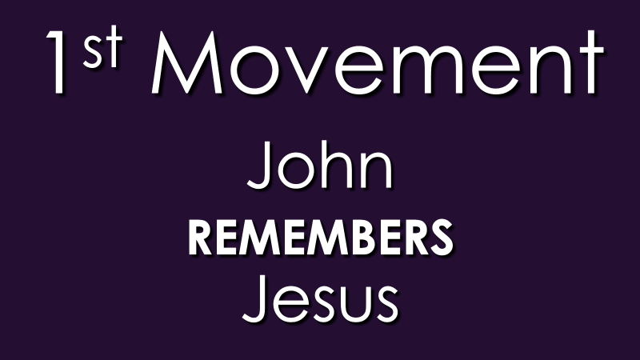
Although John doesn’t name Jesus until the very end of this one, long, sentence; written as it is, with many moving parts; in the original language the first word, translated as “that which”, is a pronoun directly tied to these nouns: “the word of life”, “the life”, “the eternal life”- all pointing to one person: Jesus Christ.

John remembers Jesus

We tend to remember the traumas, until we don’t. Just a few weeks ago the nation remembered 9/11.
And yet 20 years has passed and most people under the age of 25 simply do not remember the trauma of that day. In much the same way, very few people living today remember Pearl Harbor or even the trauma of WW 2. And no one alive today remembers the Civil War; not in its carnage; not in its rending of our nation. All academic now.

I’m not saying Jesus was tragically traumatic like those violent events. But I am saying the world changed forever with Jesus Christ. I’m saying reality, as we know it; our present existence in this world in time and space changed forever with Jesus Christ. Forever.

And John was there. It was not a childhood memory. It was not academic. With John it was visceral.
His hands had been slick with the blood of the crucified Jesus. He had felt the dead body weight of Jesus as he helped Joseph of Arimathea take the lifeless body down.

And yet his eyes had seen the risen Jesus seen the nail prints in His hands; seen the spear wound in His side. He had felt the exhale of Jesus’ breath when Jesus had breathed on them and said, “Receive the Holy Spirit.”

His nose and his taste buds had savored the fish that Jesus had cooked for them that morning by the Sea of Galilee.

And John knew, if he knew nothing else at all that everything had changed because of Jesus.

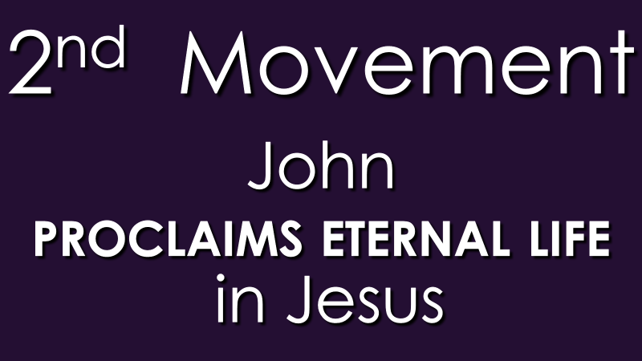

This word, proclaim ought to be staple-gunned into the sternum of every preacher who stands up before people.

This is not the word ‘kerusso’, often translated as to proclaim in the manner of the herald giving the commands of authority in the town square. Loved ones that’s the regular word for preaching: to proclaim with gravity; to proclaim with force. That’s the baseline of preaching in the New Testament.

This word is ‘apangello’. This word has to do with the authority, of the content of the message. This word does not mean to breath fire from the pulpit.

This word means to inform officially with a binding finality; to command officially with a legal authority.

In other words to “proclaim eternal life in Jesus” is not “let’s dialogue about this”; “let’s negotiate about this”.

To “proclaim eternal life in Jesus” is to say: “this is the word”; “this is the only word”; “this is the unchangeable word”; “this is the final word”; “there will be no other word.” “this is the word”

I get frustrated with any preaching that sounds apologetic or uncertain about Jesus; apologetic or uncertain about the reality of Jesus; the authority of Jesus.

In Acts 4 when Peter and John appeared before the same High Priest and High Priestly council that had put Jesus to death;

Peter said to those same men: “There is salvation in no one else, for there is no other name under heaven given among men by which we must be saved.”

And both Peter and John spoke in such a way that those who heard them were given this impression by them: “when they saw the boldness of Peter and John.”

Those same men who had crucified Jesus ordered Peter and John to “speak no more to anyone” in the name of Jesus

Peter and John – together both answered them: “Whether it is right in the sight of God to listen to you rather than to God, you must judge, for we cannot but speak of what we have seen and heard.”

John proclaimed authoritatively, commandingly, definitely” “this is the Word of eternal life”

I know that preaching these days is supposed to be more … collaborative, more … of a dialogue, more … narratively structured as a life story, more … subtle and nuanced.

I’m having none of it. Because I DO believe eternal life is at stake. I DO believe Jesus died for sin and was raised from the dead and eternal life is ONLY to be had is ONLY to be experienced by faith in Jesus.

I really believe that. You may not believe that. I DO. And I see souls at stake in that message. I see eternity in the balance in that message.

Do you believe Jesus died for your sin?
Do you believe Jesus was raised from the dead?

If you have ever had any doubt any hesitation, close with Jesus today. Right now in your heart as you’re listening to me believe upon the Lord Jesus Christ and you shall be saved.

Go home and go to your inner room and pray and close with Jesus today.
Look at what John writes: “so that you, too, may have fellowship with us”. And John follows up: “so that our joy may be complete.”

There is potential for fellowship. There is potential for joy.

Remember. The context of this entire letter is the relationship between John and these younger Christians.

Because of Jesus, in Jesus, John is holding out the potential of joyful fellowship. Joyful fellowship with God the Father. Joyful fellowship with His Son, Jesus Christ. Joyful fellowship with John, and with each other.

ALL OF IT … because of Jesus!

